**System Analysis and Design**

# Overview of System Analysis and Design

The word System is derived from Greek word Systema, which means an organized relationship between any set of components to achieve some common cause or objectives. A system is “an orderly grouping of interdependent components linked together according to a plan to achieve a specific goal.” System is created to solve problems. One can think of the system approach as an organized way of dealing with a problem. In this dynamic world, the subject System Analysis and Design (SAD), mainly deals with software development activities.

In simple words we can define a system as a collection of components that work together to realize some objectives forms a system. Basically, there are three major components in every system, namely input, processing and output.

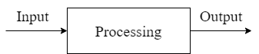

* 1. **Introduction to system analysis and Design:**

System development can generally be thought of as having two major components: System analysis and System design. System design is the process of planning a new business system or one to replace or complement an existing system. But before this planning can be done, we must thoroughly understand the old system and determine how computers can best be used to make its operation more effective. System analysis, then, is the process of gathering and interpreting facts, diagnosing problems, and using the information to recommend improvements to the system. This is the job of the systems analyst.

**System Analysis:**

Systems analysis is the process by which an individual studies a system such that an information system can be analyzed, modeled, and a logical alternative can be chosen. Systems analysis projects are initiated for three reasons: problems, opportunities, and directives. The people involved include systems analysts, sponsors, and users. The process by which systems are developed can be described by the [systems development life cycle](https://www.sciencedirect.com/topics/computer-science/system-development-life-cycle). The tasks, techniques, and tools used by the systems development life cycle can be referred as a methodology.

**System Design:**

System design is the process of defining the elements of a system such as the architecture, modules and components, the different interfaces of those components and the data that goes through that system. It is meant to satisfy specific needs and requirements of a business or organization through the engineering of a coherent and well-running system.

* 1. **Information system and its type:**

An information system is a set of interrelated components that works together to collect, process, store and breakdown the information to support decision making. Any specific information system aims to support operations, management and decision making. In other words, an information system means a collection of interrelated components which work together to **gather, process, store,**and **break down** the information to help decision making.

**Types/Dimensions:**

1. **Management Information System:**

The management information system provides aid to managers by automating different processes that were initially done manually. Business activities like business performance tracking and analysis, making business decisions, making a business plan, and defining workflow. It also provides feedback to the managers by analyzing the roles and responsibilities.

* It enhances the efficiency and productivity of the company
* It provides a clear picture of the organization’s performance
* It adds value to the existing products, introduces innovation and improves product development
* It assists in communication and planning for business processes
* It helps the organization provide a competitive advantage

1. **Decision Support System:**

A decision support system is an information system that analyses business data and other information related to the enterprise to offer automation in decision making or problem-solving. A manager uses it in times of adversities arising during the operation of the business. Generally, the decision support system is used to collect information regarding revenue, sales figures or inventory. It is used across different industries, and the decision support system is a popular information system.

1. **Transaction Processing System:**

The transaction processing system automates the transaction collection, modification, and retrieval process. The peculiar characteristic of this type of information system is that it increases the performance, reliability and consistency of business transactions. It helps businesses perform daily operations smoothly without hassle.

1. **Experts System:**

Experts systems include expertise in order to add managers in diagnosing problem or in problem-solving. These systems are based on the principle of artificial intelligence research. Experts System is a knowledge-based information system. It uses its knowledge about a specify are to act as an expert consultant to users. Knowledge-base and software modules are the consultant of an expert system. These modules perform inference on the knowledge and offer answers to a user’s question.

* 1. **Stakeholders of Information System:**

In the information system the system owners, system users, system designers, system builders and all of the above system analysts and the project managers all these are commonly known as the stakeholders. Whatever their roles in an organization are it doesn’t matter, all the thing common in them are that, they are information workers. These are some of the persons who are known as Information System stakeholders:

* System Owners
* System Users
  + Internal System Users
    - Clerical and Service workers
    - Technical and professional staffs
    - Supervisors, Middle managers and executive managers
  + External System User
    - Customers
    - Suppliers
    - Partners
    - Employees
* System Designers
  + Database Administrators
  + Network Architects
  + Web Architects
  + Graphics Artists
  + Security Experts
  + Technology specialists
* System Builders
  + Application programmers
  + System programmers
  + Databases Programmers
  + Network Administrators
  + Security Administrators
  + Webmasters
  + Software Integrators
* System Analysts
  1. **System Development Life cycle (SDLC):**

Software Development Life Cycle (SDLC) is a process used by the software industry to design, develop and test high quality software. The SDLC aims to produce a high-quality software that meets or exceeds customer expectations, reaches completion within times and cost estimates. SDLC is a process followed for a software project, within a software organization. It consists of a detailed plan describing how to develop, maintain, replace and alter or enhance specific software. The life cycle defines a methodology for improving the quality of software and the overall development process.

The following figure is a graphical representation of the various stages of a typical SDLC.

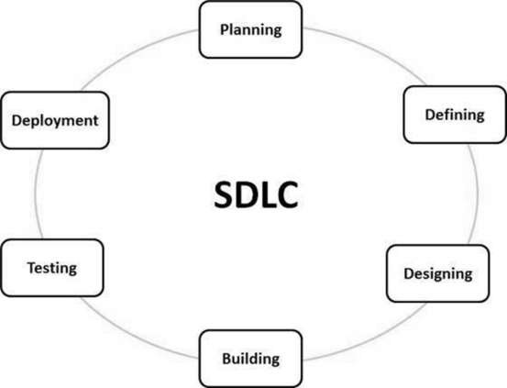

1. **SDLC Model:**

There are various software development life cycle models defined and designed which are followed during the software development process. These models are also referred as Software Development Process Models". Each process model follows a Series of steps unique to its type to ensure success in the process of software development.

Some of the SDLC models are:

* Waterfall Model
* Spiral Model
* Prototype Model